Ox | Input Binary | Output Binary
0 | 0000 | 0000
1 | 0001 | 0001
2 | 0010 | 0010
3 | 0011 | 0011
4 | 0100 | 0100
5 | 0101 | 0101
A | 1010 | 1010
B | 1011 | 1011
C | 1100 | 1100
D | 1101 | 1101
E | 1110 | 1110
F | 1111 | 1111
4-bit register with D Flip Flops

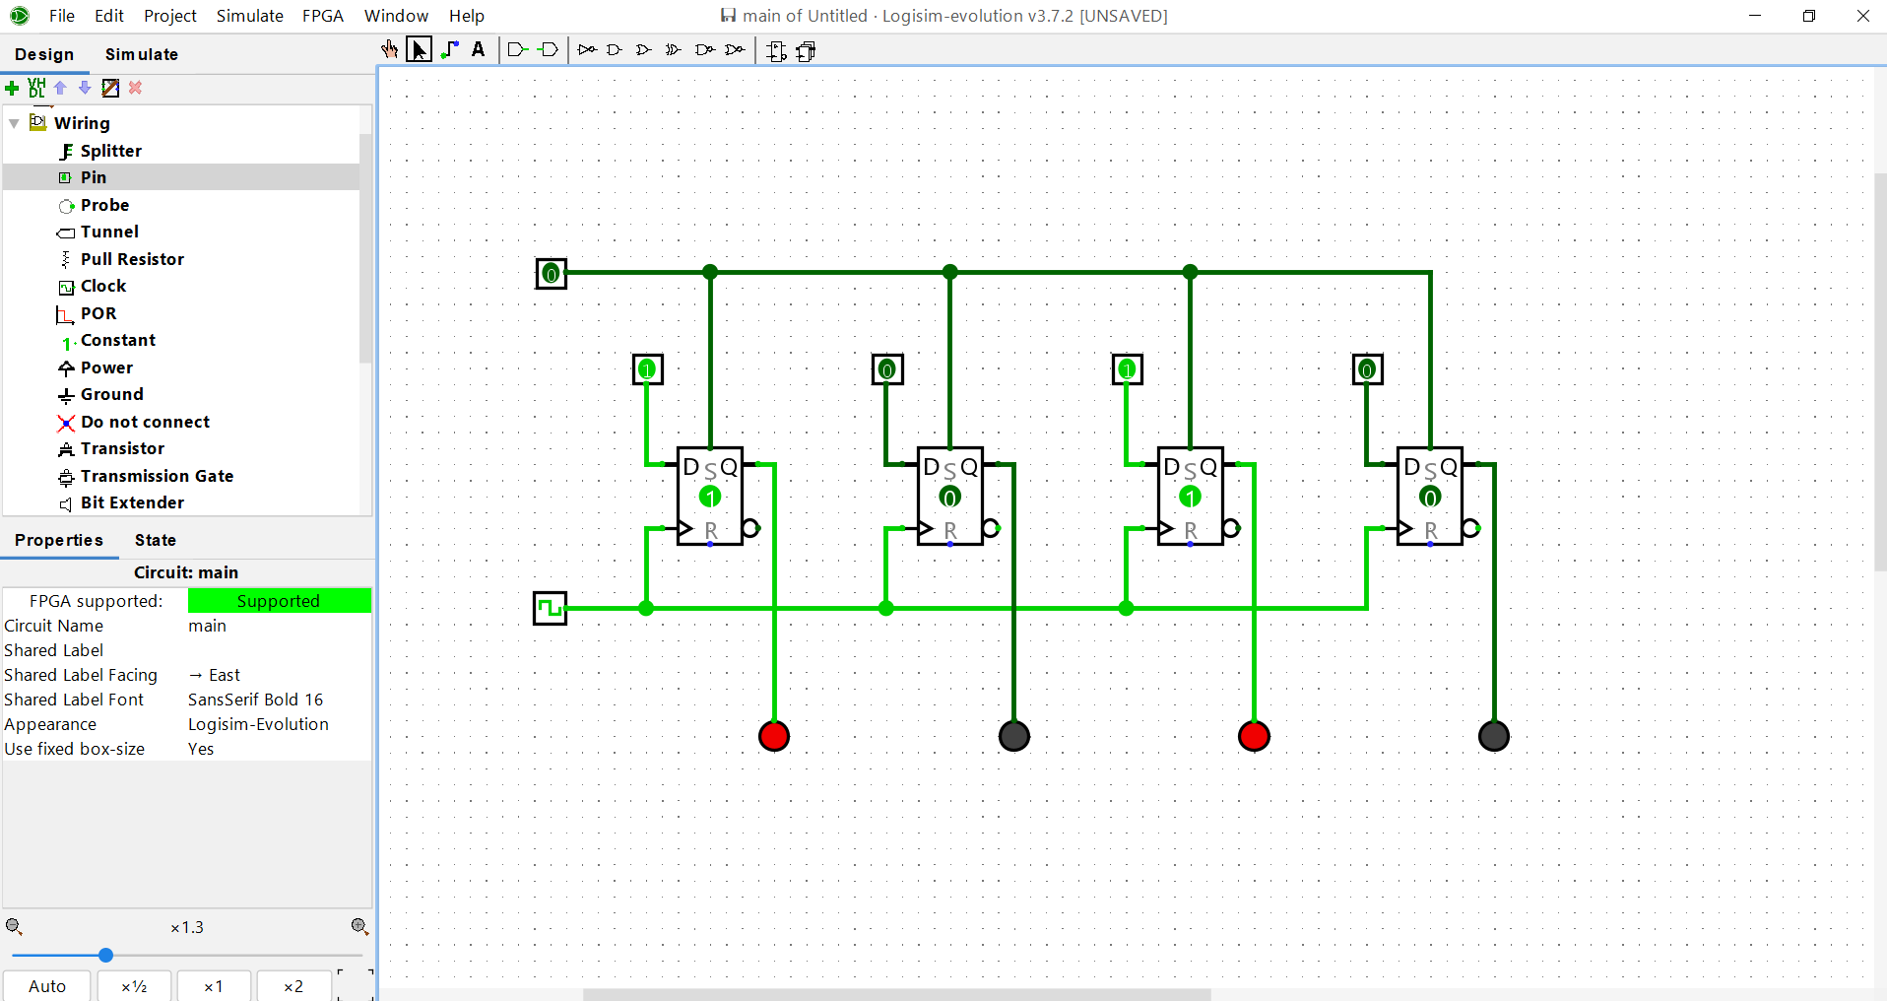
Counter are often used to show the information for counting task by showing the decimal number so that the user know the total number that is being counted.
A ripple counter is where a counter where a clock is being clocked into the first flip flop and the other flip flops are clocked with the previous flip flop.

3-bit Ripple counter using a JK flip-flop
(Countdown)
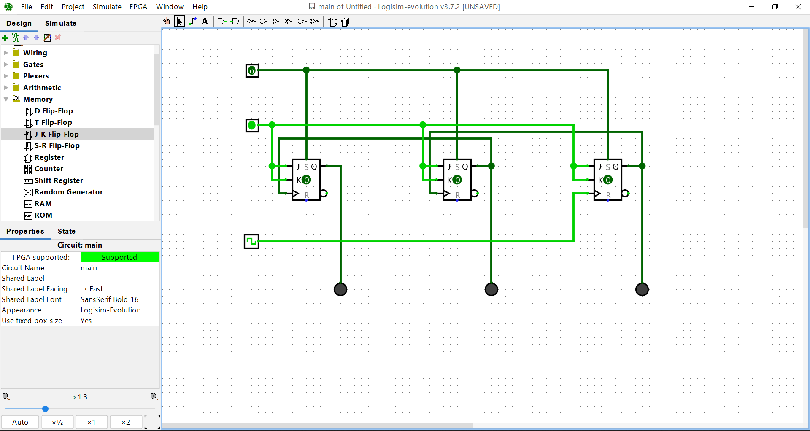
Mod 6 counter (using JK Flip Flop)
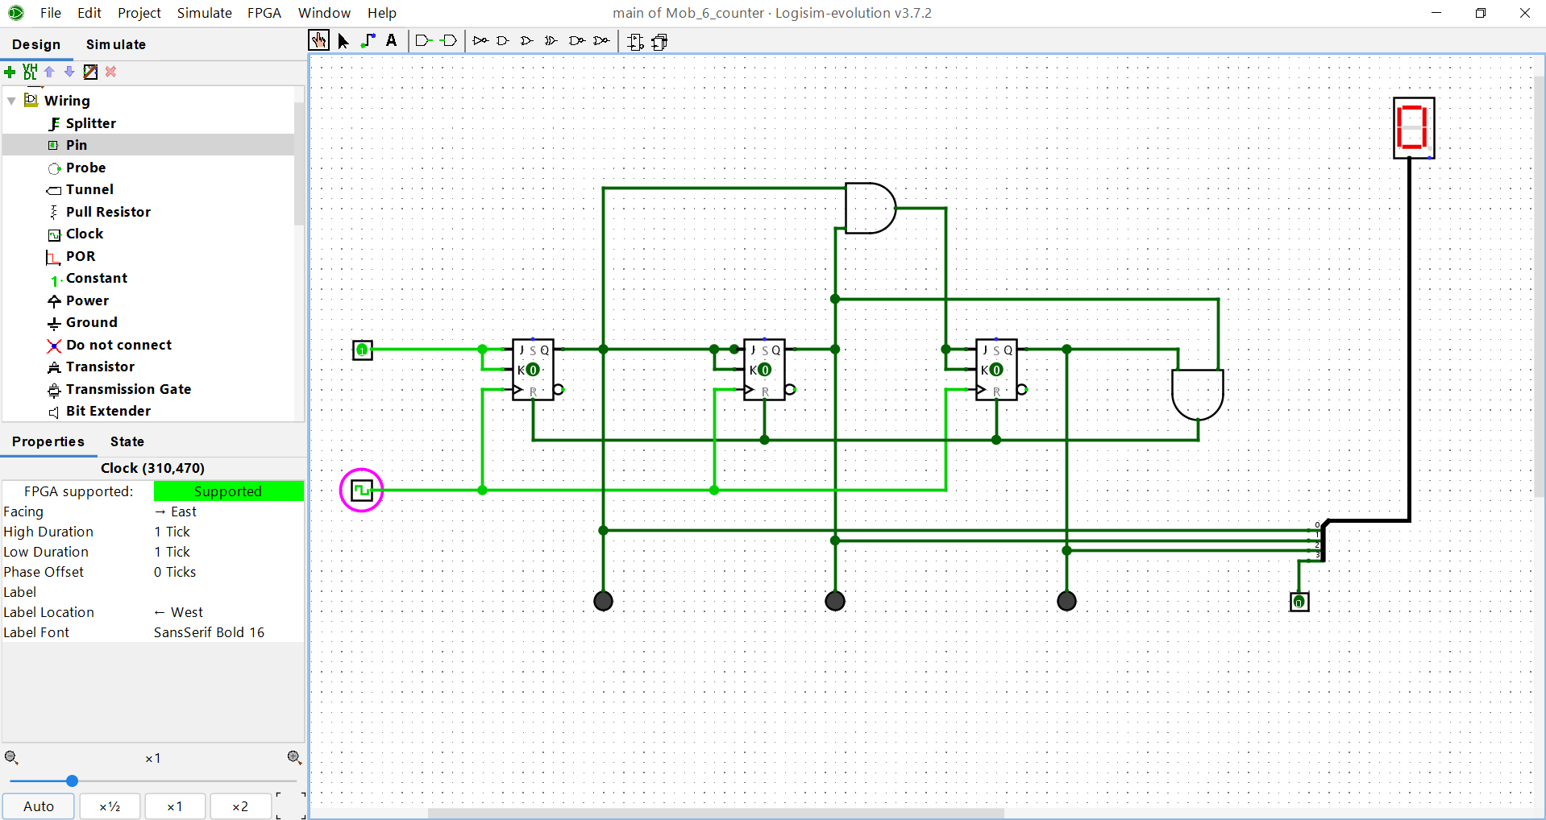
It is significant to make sure that the counter doesn’t enter the illegal state so that it will be able to run smoothly without any problem.

